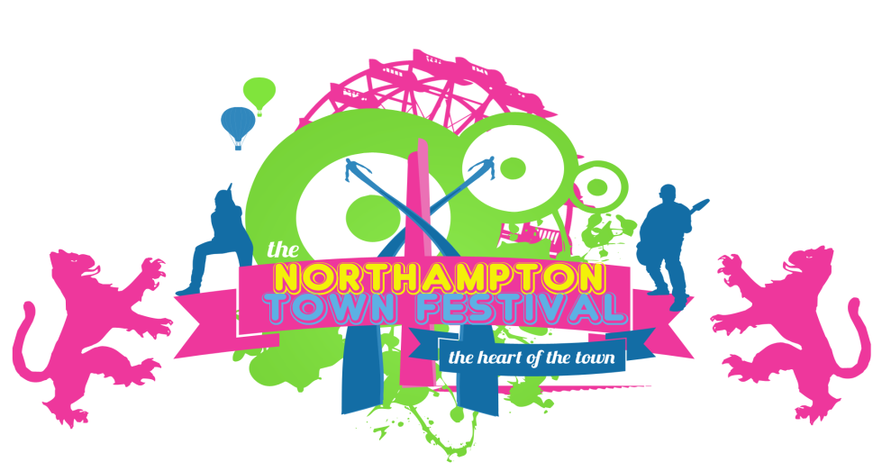

**TRADERS & STALL HOLDER**

**TERMS & CONDITIONS**

**PAYMENT:**

Payment must be made before **Friday 10th June**  BACS is the preferred method of payment. Cheques will be accepted but must be received prior to April 29th to ensure they have cleared by **Friday 10th June** Payment must be made in full; part-payments will not be accepted. Any cheques must be made payable to Show Time Events Group Ltd, 7 Tudor Court, Wootton Hope Drive, Wootton Fields, Northampton NN4 6FF.

**Account Details:**

Bank: NatWest

Account Name: Show Time Events Group Ltd

Sort Code: 54-10-53

Account No: 18154387

If payment is not received by stipulated dates, the stall offer may be withdrawn and the pitch reallocated.

NO REFUNDS will be given once payment is made.

No rebates will be given to traders as a result of bad weather, cancellation on the grounds of war or terrorism, cancellation at the request of the police or government, a change of performance programme or necessary re-siting of stalls. The festival will not accept responsibility for the level of trading during the event.

The Festival does not accept any liability for loss or damage arising directly or indirectly from acts of terrorism as defined in the UK Terrorism Act 2000.

**TRADE:**

**1.** The Licence to trade for 2016 is from 10.30 – 23.00 Saturday 2nd July 2016 & Sunday 3rd July 2016 10.30 – 23.00.

**2.** Traders must be onsite and stalls set by 10.00 and all vehicles removed from the ground by 10.00.

**3.**Traders must only sell approved goods specified in their application and agreed with Show Time Events booking team, sales for any other products are strictly forbidden.

**4.** Concessions have been agreed separately for sales of alcohol and food. If any of these goods are brought on-site by traders to sell,they will be confiscated and returned after the event.

**5.** The Festival reserves the right to reallocate or re-site stalls upon arrival at site.

**6.** Unauthorised Northampton Town Festival logos on any goods i.e. T-shirts, hats, craft goods or disposables will be confiscated.

**7.** The sale of counterfeit merchandise is prohibited.

**8.** The 2016 Names and Trading Disclosures regulation requires all traders to clearly display their business name and registered address.

**9.** Traders must display their trading name as per their application on the front of their stall (minimum size A4).

**10.** Under the Code of Practice on Powers of Entry, for the purposes of Northamptonshire Trading Standards, traders are on notice that a visit may take place over the festival period.

**11.** Traders must co-operate fully with festival security in any search of vehicles or stalls if required.

**12.** Animals are allowed on-site, but must be kept under control at all times or you will be asked to remove them.

**PASSES AND VEHICLES:**

All vehicles brought on-site are at the risk of the trader.  These must be suitably insured. The festival cannot take responsibility for any loss or damage that may occur.

No Vehicles on the show ground after 10.00.

No motorbikes, quad bikes or buggies are allowed on-site.

Vehicle passes are non-transferrable. Any vehicles found to be on-site without the correct passes will be charged parking, one pass per stall.

**SERVICES**

1. NO GENERATORS are allowed on-site.
2. All trader sites will be constantly inspected during the festival.
3. Waste water must be put in the drains provided. Disposal of waste water (from business or personal use) directly onto the ground or into ditches is prohibited.
4. Traders must not bring their own toilets or showers.
5. Any Trader found in breach of these conditions will be stopped from trading with immediate effect.
6. All rubbish must be moved daily to the skips provided.

**LEGAL & LICENCE REQUIREMENTS**

Your stall is subject to inspection by members of Northampton Town Festival’s own safety team as well as by Local Authority and Fire Brigade officers.  Traders must comply with general legislation relating to Health & Safety and CDM 2015.  This means working safely to build/dismantle the stall, using the correct Personal Protective Equipment (PPE).  
Please remember the Festival is a building site particularly during the build and break, you MUST ensure your children are kept under close supervision at all times and wear appropriate PPE.

Fire Risk Assessments are required by law. These must be available for inspection at all times and include information on preventing fire and action to be taken if a fire breaks out.  You will be required to provide your own extinguishers, signs, training etc.

Traders are not permitted to have open fires at the back of the markets. BBQ’s and contained fires may be permitted on agreement with Market Managers.

Traders must be prepared for all weather conditions however MUST NOT bring straw or hay on-site.

Traders must adhere to the Smoke Free legislation. All stalls must display at least one A5 ‘NO SMOKING’ sign.

PROHIBITED ITEMS

Items not permitted on-site: Body piercing equipment, generators, lasers, sky lanterns, fireworks, nitrous oxide. Products that are deemed ‘unfit for human consumption’ and used as Legal.

Weapons or potential weapons are not permitted on-site and will be confiscated.

TRADERS ARE REQUIRED TO COMPLY WITH THE TERMS AND CONDITIONS OF THE SITE LICENCE.

If a trader is closed down and/or evicted from site for contravening the licence, any of the above Terms and Conditions or Environmental Health Standards, they shall not be entitled to any rebate.

Please sign a copy and bring it on the day.

I have read and understood all the terms and conditions of trade let and will adhere to all conditions.

I Print Name: __________________________________________

Of Print Company: _______________________________________

Signed: ________________________________________________

Dated: ______________________________